 | Open Source Developement


TRDP
Train Real Time Data Protocol

System Architecture & Design Specification
Document reference no: TCN-TRDP2-D-BOM-O19-01

Author : | Bernd Löhr
Organisation : | Bombardier
Document date: | 31 May 2012
Revision: | 1
Status: | draft

Dissemination Level
PU | Public
PP | Restricted to other programme participants (including the Commission Services)
RE | Restricted to a group specified by the consortium (including the Commission Services)
CO | Confidential, only for members of the consortium (including the Commission Services)

DOCUMENT SUMMARY SHEET

Participants
Name and Surname | Organisation | Role

History
V1 | 31 May 12 | Bernd Löhr | Initial version

Table of Contents
Table of Contents 3
Table of Figures 4
Table of Tables 4
1. Introduction 5
1.1. Purpose 5
1.2. Intended Audience 5
1.3. References/Related Documents 5
1.4. Abbreviations and Definitions 5
2. System Description 6
2.1.1. Overview 6
2.1.2. Application/Session layer handling 6
2.1.3. Process Data 7
2.1.3.1. Publish 8
2.1.3.2. Subscribe 8
2.1.4. Message Data 8
2.1.5. Processing 8
2.1.6. Statistics 11
2.1.7. VOS 11
2.1.8. Source Files 11
2.2. Build System 12
2.2.1. Command Line 12
2.2.2. IDE 12
2.2.2.1. Xcode 12
2.2.2.2. Visual C 12

Table of Figures
Figure 1: Functional Layers 6
Figure 2: Main Data Structures 7
Figure 3: Sending Process Data 9
Figure 4: Call Sequence for Subscription 10

Table of Tables
Table 1: References 5
Table 2: Abbreviations and Definitions 5

Introduction

Purpose
This document describes the basic design of the TRDP protocol stack and may aid in extending and including further protocol features apart from process data handling.

Intended Audience
The intended audience is the programmers, who want to add additional features and/or want to support more target systems.

References/Related Documents
Reference | Number | Title
[Wire] | IEC51375-3-2 | TRDP Protocol (Annex A)
[1] | refman.pdf | TRDP Light (generated from source code by Doxygen)
Table 1: References

Abbreviations and Definitions
Abbreviation | Definition
API | Application Programming Interface
IDE | Integrated Development Environment
MD | Message Data
PD | Process Data
QoS | Quality of Service
TAU | TRDP Application Utility (Function calling prefix)
TLC | TRDP Light Common (Function calling prefix)
TLP | TRDP Light Process data (Function calling prefix)
TLM | TRDP Light Message data (Function calling prefix)
TTL | Time To Live
VOS | Virtual Operating System
Table 2: Abbreviations and Definitions

System Description

Overview
The TRDP prototype stack consists of the following functional groups:
- Application/Session layer handling
- Process Data handling (publish/subscribe)
- Optional Message Data handling
- Statistics handling
- Virtual Operating System

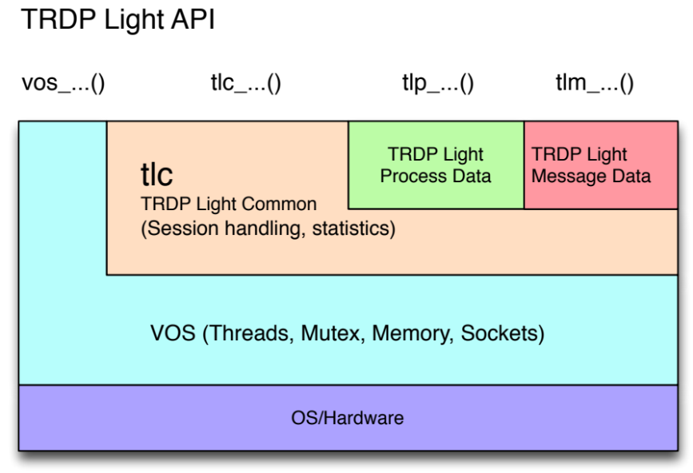
Figure 1: Functional Layers

Application/Session layer handling
The application/session layer functions handle the basic resource management – they register a session of a client application and control the overall behaviour and options for that session. The same application can have several sessions open at the same time.
Each session is internally represented by an instance of the data object TRDP_SESSION_T. Sessions are maintained by a singly linked list.

The first function an application must call before any other call to the protocol stack can succeed, is tlc_init().
Each call to tlc_init() will create a new session element and will initialize it with the supplied default parameters.
Only the very first call to tlc_init() will reserve memory and will create a recursive mutex to eventually protect concurrent access to the session data.
On successful initialization a session handle will be returned and will be used by the caller to select the right session. If the application quits or doesn’t need the session anymore, it should release it by calling tlc_terminate().
The session handle is actually the pointer to the memory area reserved for the session and must be checked for validity before dereferencing (using isValidSession()).

To allow different packet options for PD, like different TTLs and QoS values, and open sockets are quite expensive, the number of concurrent sockets should be limited. In tlc_init() a pool of socket descriptors is created and maintained. If a new publish call is done the pool of already open sockets is searched for the same send parameters and source address. Either a new or an already open socket will be returned and a reference counter incremented. Handling of the socket pool is done through the functions trdp_initSockets(), trdp_requestSocket() and trdp_releaseSocket() in trdp_utils.c.

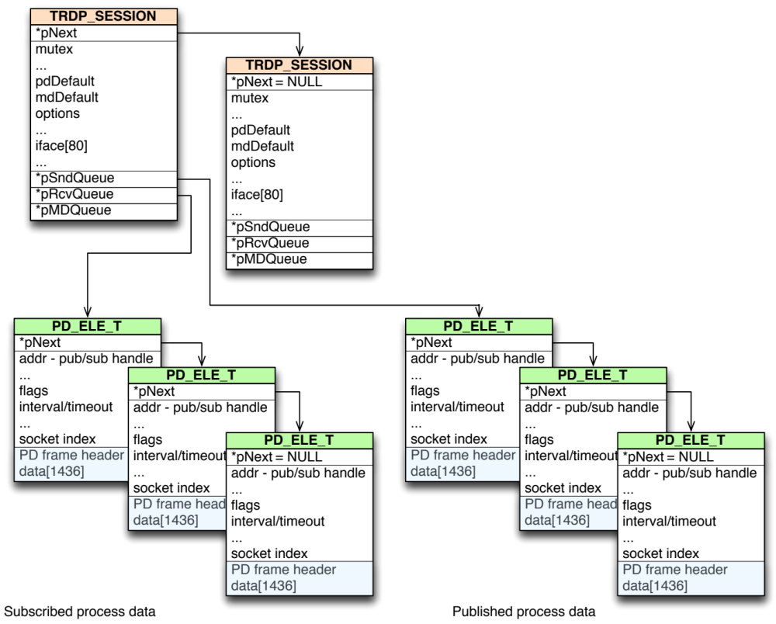
Figure 2: Main Data Structures

Process Data
For process data handling, two queues are maintained – a send and a receive queue. The send queue is filled or diminished by tlp_publish() resp. tlp_unpublish().

Publish
On publishing, the caller supplies all necessary data to construct the PD header:
- comId
- current topology counter
- source and destination IP address
- interval
- …
- send parameters
- pointer to initial data
tlp_publish() will request an adequate socket and will create and insert a new queue element into the send queue of the used session. Data is initially copied into the element by calling tlp_put(). Data can be updated at any time later using tlp_put(). It will be sent only when tlc_process() is called, though!

Subscribe
On subscribing, the functional flow is very similar to publishing; a new element is inserted into the receive queue instead and an eventual multicast group may be joined.
On tlp_unsubscribe() the subscription element will be released from the queue.

Message Data
Message data handling is a compile time option, which is controlled by #define MD_SUPPORT.
Message data will be handled in tlc_init(), tlc_process(), tlc_getInterval() and tlc_terminate(). For message data, an MD_ELE_T element must be created for each transaction to perform.

Tbd

Processing
tlc_process() is the main working function. It is the only function where sending and receiving takes place. Depending on the selected mode, whether blocking/non-blocking, using the select() function or polling, receiving process data is done.
tlc_process() has to be called at least at the lowest interval that has been defined when publishing process data. The send queue is checked for the next pending packet – if it is due, trdp_pdSend() is called.
Next job is to look for timeouts of subscribed packets. If a late packet is detected, the PD_ELE entry is marked as overdue and, if call-backs are enabled, the supplied user function will be called.
If blocking mode is on (select() is used), the receive queue is scanned for the ready socket descriptor and trdp_pdReceive() is called, getting new packet data. Again, the user supplied call-back may be called.
After process data has been handled, optionally message data will be processed depending on the state of the transaction kept in the relevant mdQueue element.

Note: Call-backs will only be called from within tlc_process(). tlc_process() must not be called from within a call-back.

To support the application in determining the right time to call tlc_process() and to minimize CPU usage through polling, the function tlc_getInterval() checks all queues for pending packets to send or receive and computes the next time when tlc_process() must be called before any timing constraints may hit. tlc_getInterval() should always be called before tlc_process().

Sample calling sequences are shown below.

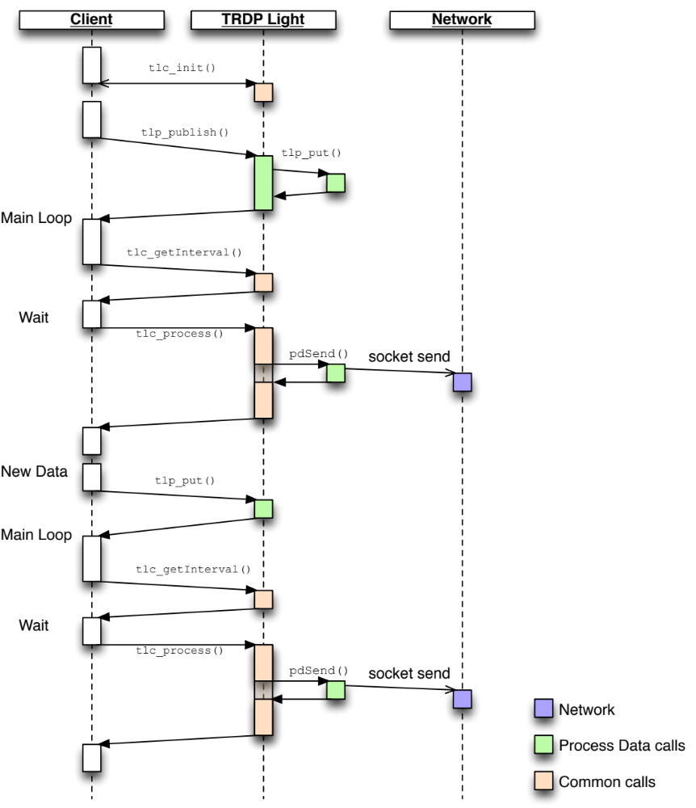
Figure 3: Sending Process Data
When receiving data (subscribe), data can be fetched either by using call-backs (out of tlc_process()) or at any time by polling with tlp_get().
A call-back, if enabled, will only originate from tlc_process() context.

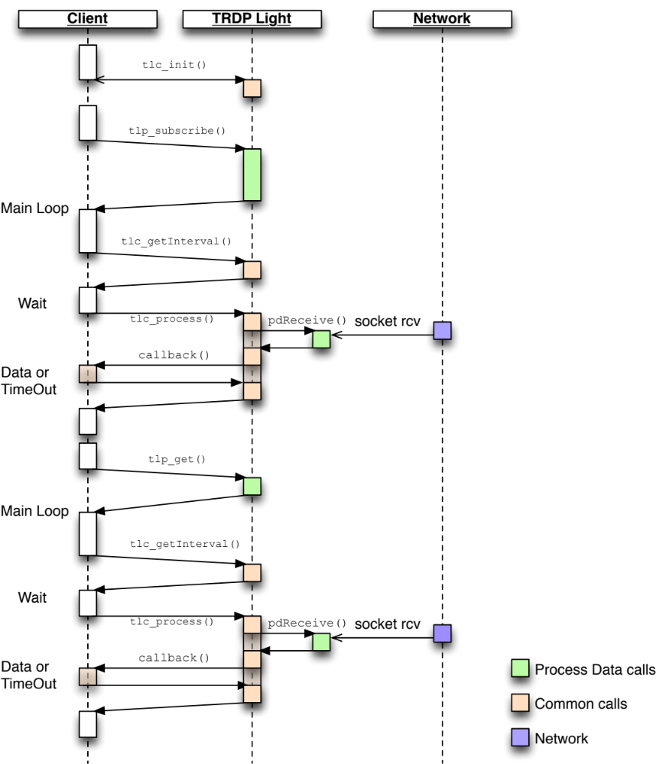
Figure 4: Call Sequence for Subscription
Detailed description of the PDCom-related functions can be found in [1].

Statistics
All functions effectively taking part in communication will update the counters kept in the global variable TRDP_STATISTICS_T gStats in the file trdp_stats.c.
To prevent accessing a global variable directly but prevent unnecessary overhead by real accessor functions, inline/makro functions are defined to set and increment specific members.
…

VOS
All calls to system dependent services like memory, network, CPU (threading) are mapped over an abstraction layer. Target dependent implementations are located in directories named after their targets.
Selecting a specific target involves changes of the Makefile and/or IDE project settings, see 2.2.1 and 2.2.2.

Source Files

File | Content
echoPolling.c | Demo echoing application for TRDP
echoSelect.c | Demo echoing application for TRDP
sendHello.c | Demo sending application for TRDP
tau_addr.h | TRDP address resolution declarations
tau_marshall.h | TRDP marshalling declarations
tau_types.h | TRDP utility interface declarations
tau_xml.h | TRDP configuration interface declarations
trdp_if.c | TRDP Light interface functions
trdp_if_light.h | TRDP Light interface declarations (API)
trdp_mdcom.c | Functions for MDcommunication
trdp_mdcom.h | Functions for MDcommunication
trdp_pdcom.c | Functions for PDcommunication
trdp_pdcom.h | Functions for PDcommunication
trdp_private.h | Typedefs for TRDPcommunication
trdp_types.h | Typedefs for TRDP communication
trdp_utils.c | Helper functions for TRDPcommunication
trdp_utils.h | Commonutilities for TRDPcommunication
vos_mem.c | Memory functions
vos_mem.h | Memory and queue functions for OS abstraction
vos_sock.c | Socket functions
vos_sock.h | Typedefs for OS abstraction
vos_thread.c | Multitasking functions

Build System

Command Line
On the top level of the project, a Makefile preset for the ‘POSIX’ target can be invoked.
With the command
Make help
the possible options are listed. For different targets and compilers, the head of the Makefile allows to change several path and configuration variables.
To generate the documentation from the source files, ‘Doxygen’ version 1.5 or higher must be installed on the host system. Depending on your installation it might be necessary to adjust a path in the file Doxyfile on the same level.

IDE

Xcode
The folder Xcode contains a project file for the Mac OS X Xcode IDE version 3.2 with several predefined targets.

Visual C
n/a

